::::Desktop:mwh logo_blue-white.png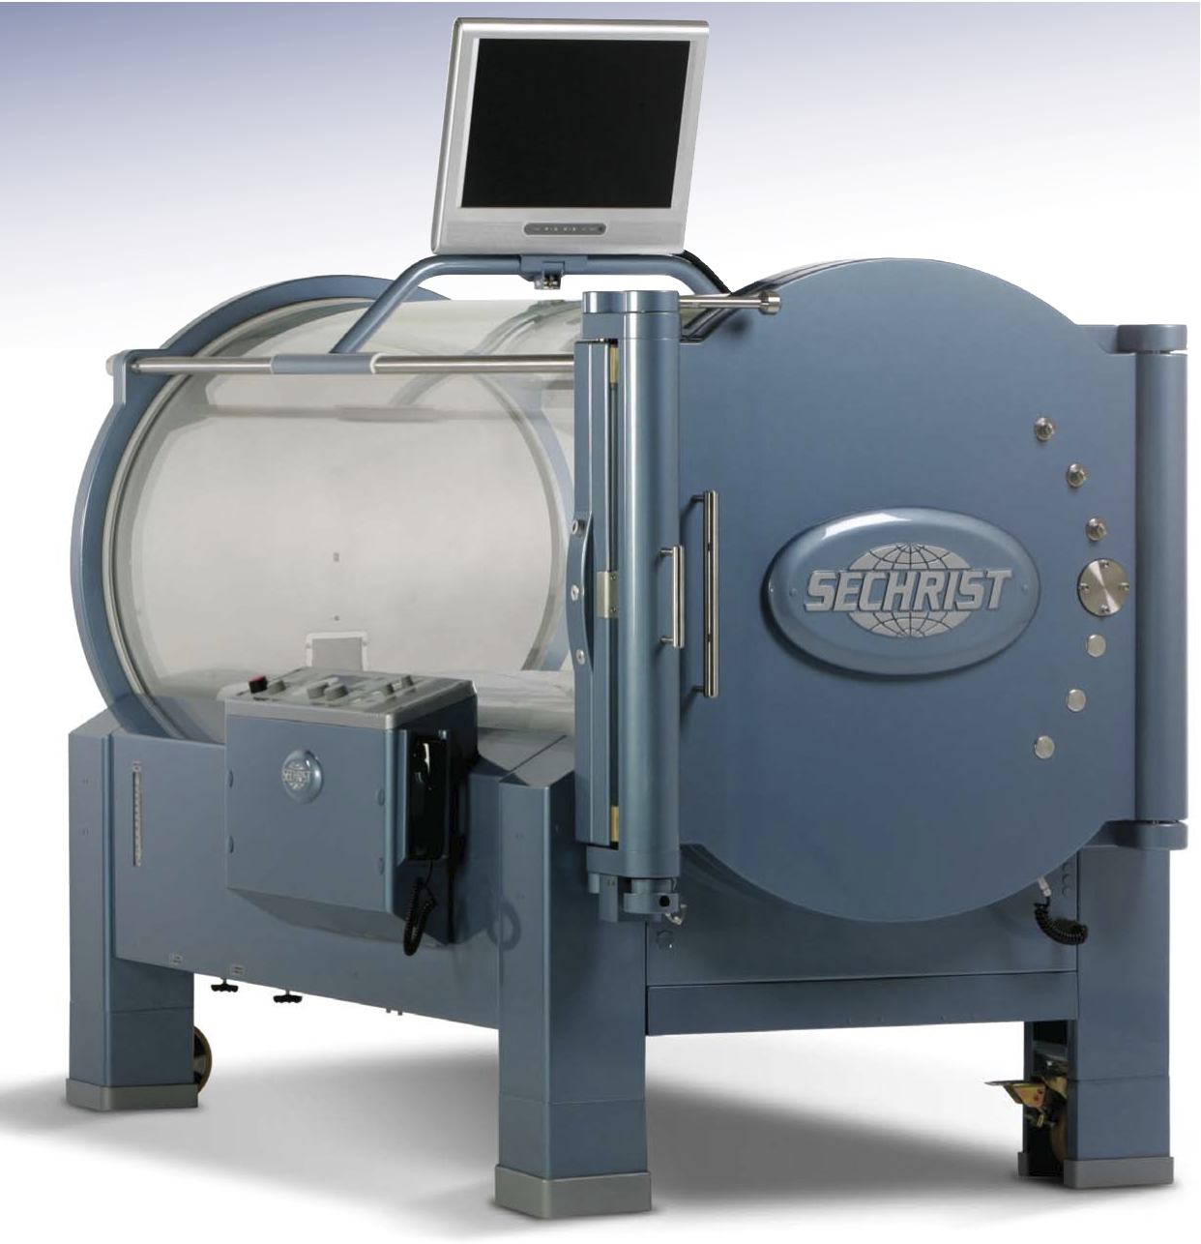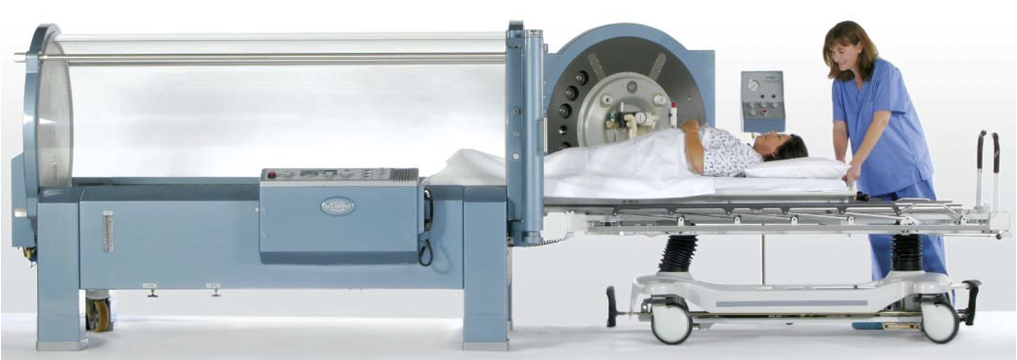

# How Do I Prepare?

Preparation for treatment involves several aspects. We provide 100% cotton garments which you will wear during all treatments. We ask that you remove all watches, jewelry, metal and synthetic material. **Do not use makeup, hair spray, cologne or lotions before your treatments.** Do not consume carbonated beverages for at least   
1 hour prior to the treatment. If you are a smoker, we ask that you stop smoking for the entire time you are receiving HBO therapy, even at home. Smoking and the use of tobacco products slows down any benefits you are likely to receive from HBO.

After you have been seen in consultation,   
a specific treatment schedule will be arranged to suit both your schedule and ours. HBO treatments are scheduled at 7:30 am, 10:00 am and 1:00 pm. Consultations are scheduled at 9:00 am and 1:15 pm. The time given to you as your treatment time is when we plan to slide you into the chamber. Therefore, you will need to arrive at the facility 15-20 minutes before your scheduled time in order to have time to change clothes.

If you are unable to take a hyperbaric treatment, please call the staff immediately so that a make up treament can be scheduled. As we strive to meet the scheduling needs of each patient, we ask you to give us a **12-hour notice** if you need to cancel or reschedule your appointment. Our answering machine can take your message 24 hours a day.

**Hyperbaric  
Medicine  
Service**

## Mission Statement

Lorem ipsum dolor sit amet, consectetur adipiscing elit. Aenean mollis tristique pellentesque. Phasellus sit amet bibendum mauris. Vestibulum ante ipsum primis in faucibus orci luctus et ultrices posuere cubilia Curae. Aliquam accumsan nunc at sem vestibulum feugiat ultrices.

Facility Name

[Street Address] [City], [State] [Zip Code]

{Phone} [Fax}  
[Web Address]

Weekdays 7:30 am to 4:30 pm

Weekend and Holidays are prescheduled.

Emergency 24 hours a day.

## Hours of Operation

# What are the Effects?

The treatment is painless. At the beginning and end of your treatment, you may notice a feeling of “fullness” in your ears, very much like the feeling when changing altitude in an airplane, driving in the mountains or diving underwater. As your eardrums respond to the changing pressure, you may hear “popping” or “crackling” noises. It is not usually painful, but if you do not fully clear your ears, you may develop an earache. To clear or pop your ears, you will have a water bottle with you in the chamber to help you swallow. We will also treat you with a decongestant spray before each treatment.

After entering the chamber, the door is closed and compression of the oxygen inside begins. You may   
feel warm for a moment until you reach the desired depth of treatment. After 10 to 15 minutes, compression is complete and the usual feeling of fullness in your ears will disappear. You will continue breathing oxygen for 90 minutes. After 90 minutes, the treatment will come to an end. You may again notice a “popping” or fullness in you ears. Rarely, patients will feel lightheaded for a few moments after the treatment. This ends quickly and does not interfere with normal activity. If you wear glasses for reading, you may have a few weeks in which you can read without your glasses. If your eyes are normal, your reading vision may temporarily worsen. This does not hurt in anyway and is temporary. Do not discard your old corrective lenses.

Heart rhythm is routinely monitored on all patients for the first treatment. For patients with a preexisting heart condition, monitoring may be done with each treatment. If you are diabetic, your blood sugar will need to be taken before and after each treatment.

# Hyperbaric Oxygen Facility

The Hyperbaric Medicine Service facility consists of 2 single person chambers. The chamber is approximately 7 feet long and 2 1/2 feet in diameter. The walls are clear acrylic plastic. During the treatment, you lie on a stretcher inside the chamber. The entire chamber is filled with oxygen so all you do is breathe normally. An open microphone inside the chamber allows the staff to hear anything you say while you are in the chamber. All patients are closely monitored by board certified staff and a physician trained in hyperbaric medicine. During a treatment, which usually lasts about 2 hours, you may sleep, listen to music or watch TV. You may bring in your own videos or DVDs.

# What is Hyperbaric Oxygen Therapy?

Hyperbaric oxygen is a medical   
treatment in which the patient breathes pure oxygen under increased pressure.   
It is administered in a single person chamber and is the treatment for many medical and surgical conditions. It may   
be the main treatment for certain conditions but is usually part of an overall plan of care involving surgery, antibiotics or other therapy.

Hyperbaric oxygen is a simple concept. The air we breathe is normally 21% oxygen at 14.7 pounds of pressure per square inch (psi). In the chamber, the pressure can be increased to as much as   
3 times normal (about 44.1 psi), and the patient breathes 100% oxygen. This increases the amount of oxygen in the blood to many times its normal levels, thereby delivering much more oxygen to all parts of the body. This increase in oxygen delivery helps improve healing and controls infection in certain conditions.

# Length of Treatment

The number of hyperbaric treatments is determined by the condition being treated. Treatments may range from 1 to 40 depending on the diagnosis. Treatments are scheduled daily and occasionally twice daily. It is vital that you be on time for treatments as any delay will affect other patients’ treatment as well as your own.