- Hospital / Facility -

Address

[Phone] [Fax]  
Website

# Hours of Operation

Weekdays 7:30 am to 4:30 pm

# What can be treated with Hyperbaric Oxygen Therapy? Hyperbaric Oxygen Therapy is divided into three categories: Emergent, Urgent and Elective

|  |  |  |
| --- | --- | --- |
| An **Emergent indication** would be defined as any medical condition in which hyperbaric oxygen therapy is the primary standard of care. The following are considered to be emergent conditions for the use of HBOT:   * Arterial Gas Embolism * Acute Carbon Monoxide Poisoning * Decompression Sickness | An **Urgent condition** is a medical condition in which hyperbaric oxygen therapy is an adjunctive modality. The following are considered to be urgent conditions for the use of HBOT:   * Chronic Refractory Osteomyelitis * Clostridial Myonecrosis * Diabetic Foot Ulcer * Compartment Syndrome * Crush Injury * Necrotizing Fasciitis | An **Elective condition** is a medical condition in which HBOT is utilized in  a supportive care modality. The following are considered to be elective indications for the use of HBOT:   * Compromised Skin Grafts * Compromised Skin Flaps * Osteoradionecrosis * Soft tissue Radionecrosis * Radiation Cystitis * Radiation Proctitis * Radiation Vaginitis |

**What is  
Hyperbaric Oxygen Therapy?**

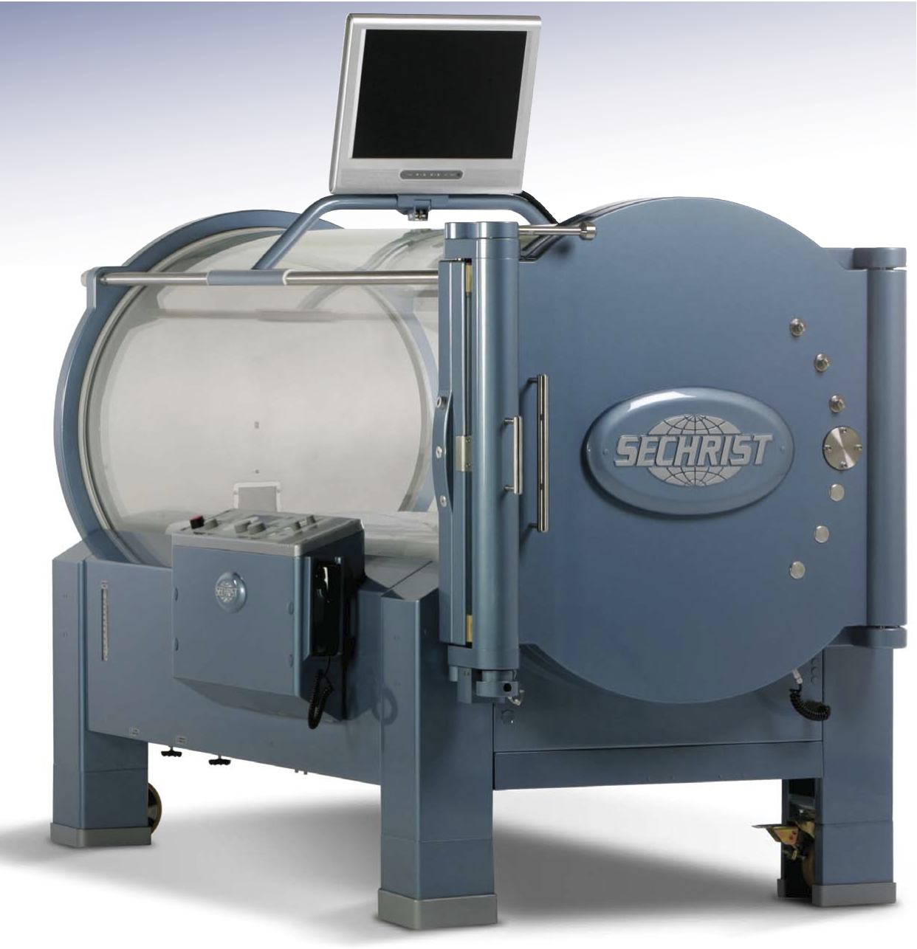

Hyperbaric Oxygen Therapy (HBOT) is a non-invasive painless mode of therapy. A patient receiving HBOT breathes 100% oxygen, at a pressure greater than sea level, while in an enclosed pressure vessel. This results in a dramatic elevation of oxygen in the blood, tissue and body fluids. HBOT can result in blood oxygen levels 15 times greater than blood oxygen levels in normobaric conditions.

During HBOT, the patient will breath 100% oxygen at a pressure of 2.0 to 3.0 atmospheres. The pressure at which a patient is treated is determined by the physician’s diagnosis. Treatment protocols have been established by the Undersea and Hyperbaric Medical Society for each indication utilized by the Hospital - Facility.

As the patient descends to the prescribed atmospheric pressure, the sensation of "popping" in their ears may occur. This effect is the result of changing pressure and occurs during pressurization (descent) and depressurization (ascent). The typical length of treatment is 120 minutes. The length of treatment may vary dependant on the treatment protocol.

At the completion of each treatment, the patient will be evaluated by one of our physicians.